Women in the 1950s

A little background: WWII veterans returning home from war helped in part spark a baby boom (a spike in population). Women who had been encouraged (see below) to help the war effort returned home from their wartime jobs. The 1944 G.I. Bill made home buying easy, so with the rise in automobile ownership, suburbs sprung out right outside cities with look alike, cookie cutter houses. Affordability of televisions at home and increasing media put pressure on people to become consumers and “keep up with the Joneses” by buying the latest appliances, such as washers and vacuums.

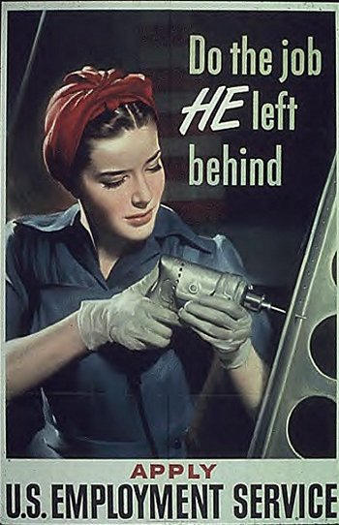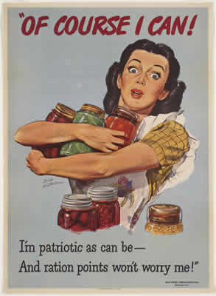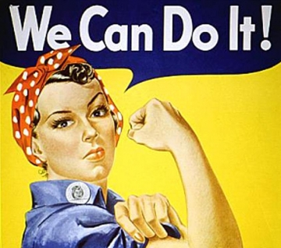

Mona Lisa Smile (Fiction movie, set in 1953’s America) YouTube clip:
http://www.youtube.com/watch?v=y8ucxVw8Oos

Questions to think about as you watch:
- What was typically valued by even highly educated women in the 1950s?

The new and available media (print and television) caused a new American ideal to arise, such as the suburban housewife seen in the television show Leave It to Beaver.

The Wisdom of Ward Cleaver (1958) YouTube clip: http://www.youtube.com/watch?v=tMZZhctPCfQ

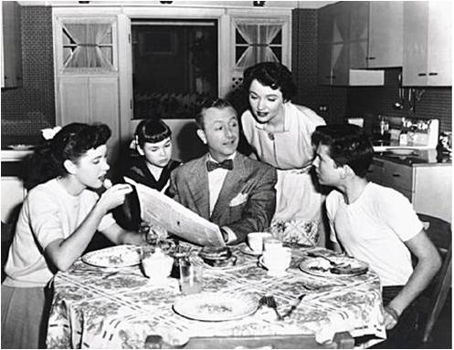

This kind of image was commonly found in magazines during the 1950s to show the ideal family of the time. With just looking at this image, what do you think life was meant to be like for the 1950s suburban woman with a husband and children? What kind of image was meant to be portrayed?

Credit: http://bookbuilder.cast.org/bookresources/42/42401/165430_1.jpg

Document C
Historian Joanne Meyerowitz (Modified)
"The Woman's Home Companion (a popular women's magazine) conducted opinion polls in 1947 and 1949 in which readers named the women they most admired. In both years the top four women were [women involved in politics]. The postwar popular magazines were also postive about women's participation in politics. The Ladies' Home Journal had numerous articles that supported women as political and community leaders. One article in the Ladies' Home Journal from 1947 encouraged women to "Make politics your business. Voting, office holding, raising you voice for new and better laws are just as important to your home and your family as the evening meal or spring house cleaning."
Source: Joanne Meyerowitz, "Beyond the Feminine Mystique: A Reassessment of Postwar Mass Culture, 1946-1958. "The Journal of American History, Vol. 79, No. 4 (Mar., 1993), pp. 1455-1482. Meyerowitz examined 489 articles in eight monthly magazines from the 1950s.

Document D
Historian Alice Kessler-Harris (Modified)
"At first glance, the 1950s was a decade of the family... But already that family was flashing the warning signals... Homes and cars, refrigerators and washing machines, telephones and multiple televisions require higher incomes... The two-income family emerged. In 1950, wives earned wages in only 21.6 percent of all families. By 1960, 30.5 percent of wives worked for wages. And that figure would continue to increase. Full- and part-time working wives contributed about 26 percent of the total family income."
Source: Alice Kessler-Harris, Out to Work, 2003, pp. 301-302.

