“The Troubles” of Northern Ireland
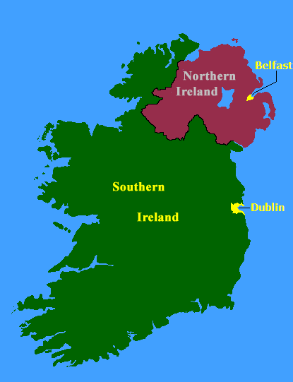
The island of Ireland is divided into two parts. Northern Ireland, in the northeast, is a part of the United Kingdom. The Republic of Ireland is an independent country.
A conflict between the two main religious groups, the Protestants and the Catholics, has been going on for over four hundred years. In the second half of the 20th century violent clashes between the two groups killed over 3,000 people. Towards the end of the century a new peace agreement was signed that was expected to bring peace to Northern Ireland.

People
Northern Ireland’s population consists of two main groups. Half of the people are Protestants. They are descendants of Scottish and English settlers who came to the area in the 17th century. About 40% are Irish Catholics. The two groups live separately in their own neighborhoods.
Northern Ireland's capital is Belfast, a city of about 500,000. Londonderry in the northwest is Northern Ireland’s second largest city.
Beginning of the conflict
Henry VIII turned England into a Protestant Country, most people in Northern Ireland remaind Catholic. The following English monarchs were determined to make England Protestant and in many ways there were successful.
The Monarch wanted England to be Protestant. Monarch James the first sent thousands of Protestants to Northern England and allowed them to take the Catholic peoples land from them. The Catholics were left with nothing. They rebelled against this policy but they were defeated and left with no land.
By the beginning of the 19th century Britain controlled the whole island.

The Division of Ireland
Throughout the 19th and 20th century many Irish groups fought against England for independence. However, the Northern part of Ireland wanted to stay with Great Britain. However the rest of Ireland wanted to be independent.
In 1922 the island was divided. Six counties that were Protestant stayed part of Great Britain. The rest of the Island declared Independence in 1949.
Up until 1972 Northern Island ruled itself. During this time the Catholic (the minority) were discriminated against by the Protestants (majority). The Catholics did not have the same rights and opportunities as the Protestants. The barely found jobs, were paid less, received less benefits from government, and were harassed by the police. Much like the situation with Whites and African Americans in the United States.
The Troubles

In the late 1960’s riots broke out between the Protestants and Catholics in Belfast. The violent decades became known as “the troubles”. Much like the civil rights movement in the United States.

In 1970 British soldiers sent in troops to Northern Ireland to restore peace and rule Northern Ireland since they were unable to rule themselves.

Events escalated when 13 unarmed demonstrators were shot in a protest march. It was called Bloody Sunday.

Both religious groups built paramilitary organization. On the Catholic side the Irish RepublicanArmy (IRA) carried out attacks on Protestants in the North. It want to force the British out so they could create a single Catholic state on the island. On the Protestant side the Ulster Defence Association and others terrorized the Catholics.
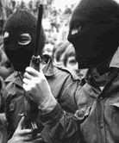
In 1980 the IRA started attacking the British soldiers to force them out of Ireland. They planted bombs in London, kidnapped and killed government official in Great Britain. Activists were arrested and put in prison.
In the 1990’s the British government began to create a peaceful solution to the troubles. In over 30 year of violence, over 3,000 were killed.
Paramilitary methods
As paramilitary groups became more organised and sophisticated, and embarked on offensives, the death toll steadily rose. New methods of violence, such as the car bomb and plastic explosives, supplemented the more established use of firearms. Bombs detonated with little or no warning produced high death tolls. In July 1972, nineteen IRA bombs across Belfast killed nine people on a day that became known as Bloody Friday.
March 1973 saw a concerted IRA bombing campaign in England begin in earnest. The following year, 21 people were killed and over 180 injured by explosions in two Birmingham bars. In total, around 250 people were killed in England and the Republic of Ireland during the Troubles. People died in Europe as well, as the IRA sought diplomatic and military targets.
Shootings became routine among paramilitaries from both sides and continued throughout the Troubles.

The Peace Process
As time went on both sides realized violence would not solve the conflict. The IRA promised to quit violent acts and signed an agreement on Good Friday 1998.
Main points: Future of Ireland should be determined by people, all political groups share power in N. Ireland, law making powers established, prisoner should be released, all weapons must be given up in 2 year, Republic of Ireland will seek reunification.
The people of N. Ireland agreed to accept treaty and the new assembly was elected. However, the two groups were not able to trust each other and the IRA would not give up their weapons. Therefore the British reimposed their rule. In 2005 the agreed to finally give up weapons. In 2007 they finally came together and united as an assembly. However…..old habits die hard. There is still a lot of tension.

