- Felippo Lippi: Madonna and Child with Two Angels
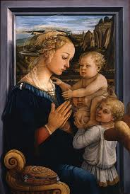

- Bathing Venus, Roman Artist Unknown
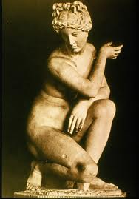
- Titian: Venus and Adonis
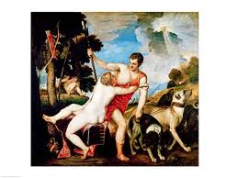
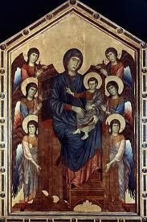
- Cimbue: Madonna and Child in Majesty

- Artist Unknown:Grave Stele of Hegeso

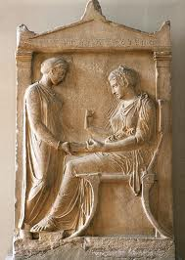
- Artist Unknown: Bayeux Tapestry
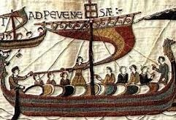
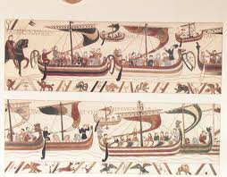

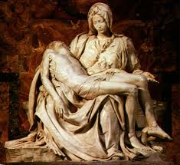
- Michelangelo: Pieta

