Ottomon Empire:
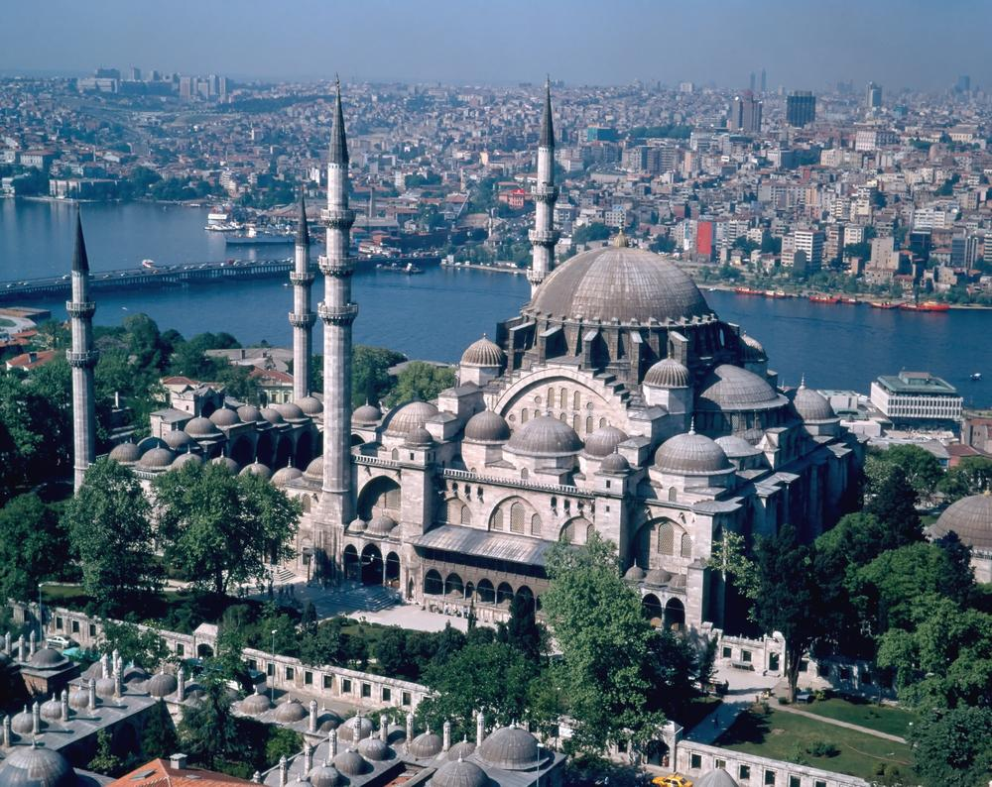
Europe slowly began trading with the Ottoman Empire through the Cape of Good Hope during the Middle Ages. They quickly saw that their region of the World was far behind the Middle East and their advancements. This was a wake up call to Europe. You will read and look at some of the pictures below to illustrate how Europe and the Ottoman Empire.
The Sultan Ahmed built this Mosque in the early 1600’s, how does it differ from the buildings of Europe?
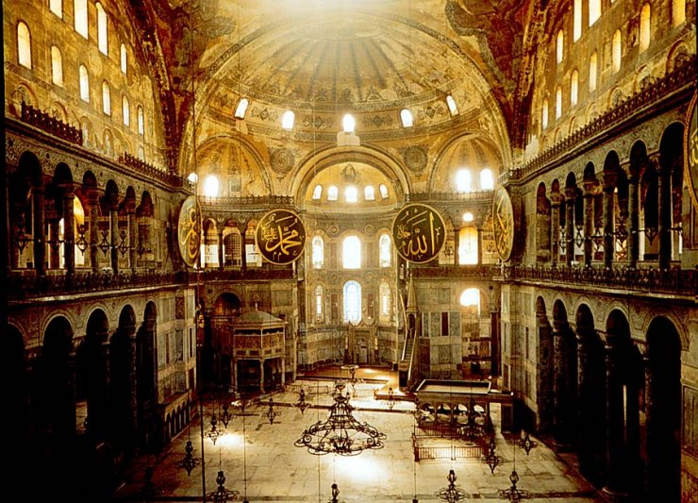
Hagia Sofia – Mosque in Istabul

Ottoman Empire Capital:
Istanbul was the capital and the one of the “wealthiest and most cultured cities of the early modern world” as well as being the center for military campaigns.
Government and Royal Families:
Mehmed the Conqueror presented himself as the worrier sultan and emperor of Europe and Asia, as well as the Black Sea and the Mediterranean
Mehmed laid the foundation for a tightly centralized, absolute monarchy.
His army were composed of two major groups: a light cavalry and a volunteer infantry, and faced no serious rivals.
He worked on expansion his whole life and toward the end he launched an invasion of Italy but his successors abandoned his plan
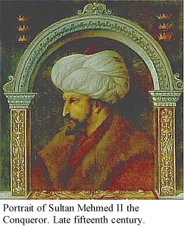
Suleyman the Magnificent brought about the climax of imperialism, and he promoted expansion into Southwest Asia and Europe.
He went on to conquer prominent cites and states in the Middle East and under him, the Ottoman navy became a major power Black and Aegean Sea.
Their navy allowed them to challenge Christian European ships throughout the world’s ocean
The emperor’s inherited his predecessors power as well as gained power from his militarily abilities. Successful warriors received high standing. The society of the Ottomans reflected steppe society. Members of the royal family often managed parts of the state governments. Women were not allowed to wield great authority according to Islamic views; however, following the example of Chinggis Khan, women played a prominent role in politics by manipulating affairs from their husband’s side.
Household:
Wealthy homes in the Ottoman Empire were built around a central courtyard. This shows how the family life and the public affairs were separated in the Ottoman Empire. The lifestyle of middle and lower classes are unknown.
The Ottoman households were harem, or forbidden to male outsiders (for women).
The Ottoman family was patriarchal. Women who lived in rural regions usually worked in the fields. A woman who lived in the city could have spent her day doing household chores, supervising servants, weaving, watching children, or praying. Except for special occasions such as celebrations, life outside the house for women was limited. The parents chose who their children were to marry.
Culture and Religion:
Coffee houses were a favorite gathering place of the Ottomans.
Astounding architectural structures made a sky line based on styles from the Byzantine.
Their society reflected mainly Islamic values as Islam was the prominent religion.

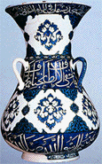
Economy:
The Ottomans got constant new sources of revenue as their empire expanded.
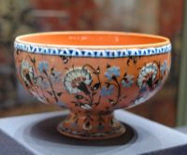
The empire became wealthy as they received jizya tax from non-Muslims in return for religious freedom and protection.
Inventions and Healthcare and Education
The Ottomans had many inventions and advancements during the height of the Ottoman empire. They were effectively using cannons during warfare, they had military schools and most of their muslim citizens were educated and literate (they could read). In addition, they created hospitals, medical schools, they were the first to use paper, the learned that germs made people sick (not religious figures punishing you) , they performed eye surgery and established quarantines.

Medieval Europe:

Politics:
For safety and for defense, people in the Middle Ages formed small communities around a central lord or master. Most people lived on a manor, which consisted of the castle, the church, the village, and the surrounding farm land. These manors were isolated, with occasional visits from peddlers, pilgrims on their way to the Crusades, or soldiers from other fiefdoms.
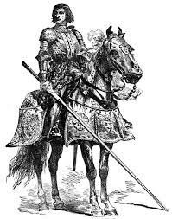
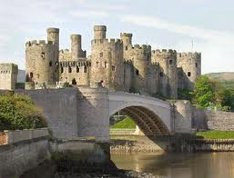
In this "feudal" system, the king awarded land grants or "fiefs" to his most important nobles, his barons, and his bishops, in return for their contribution of soldiers for the king's armies. At the lowest echelon of society were the peasants, also called "serfs" or "villeins." In exchange for living and working on his la nd, known as the "demesne," the lord offered his peasants protection.
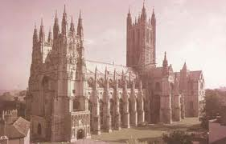
Religion (Politics)
The Catholic Church was the only church in Europe during the Middle Ages, and it had its own laws and large coffers. Church leaders such as bishops and archbishops sat on the king's council and played leading roles in government. Bishops, who were often wealthy and came from noble families, ruled over groups of parishes called "diocese." Parish priests, on the other hand, came from humbler backgrounds and often had little education. The village priest tended to the sick and indigent and, if he was able, taught Latin and the Bible to the youth of the village.
Look at the church in comparison to the townes….what does this tell you?
As the population of Europe expanded in the twelfth century, the churches that had been built in the Roman style with round-arched roofs became too small. Some of the grand cathedrals, strained to their structural limits by their creators' drive to build higher and larger, collapsed within a century or less of their construction.
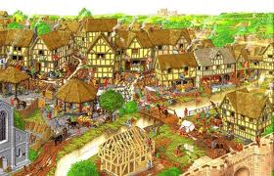
Homes
Most medieval homes were cold, damp, and dark. Sometimes it was warmer and lighter outside the home than within its walls. For security purposes, windows, when they were present, were very small openings with wooden shutters that were closed at night or in bad weather. The small size of the windows allowed those inside to see out, but kept outsiders from looking in.
Many peasant families ate, slept, and spent time together in very small quarters, rarely more than one or two rooms. The houses had thatched roofs and were easily destroyed.
Health
s the populations of medieval towns and cities increased, hygienic conditions worsened, leading to a vast array of health problems. Medical knowledge was limited and, despite the efforts of medical practitioners and public and religious institutions to institute regulations, medieval Europe did not have an adequate health care system. Antibiotics weren't invented until the 1800s and it was almost impossible to cure diseases without them.
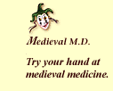
There were many myths and superstitions about health and hygiene as there still are today. People believed, for example, that disease was spread by bad odors. It was also assumed that diseases of the body resulted from sins of the soul. Many people sought relief from their ills through meditation, prayer, pilgrimages, and other nonmedical methods.
The body was viewed as a part of the universe, a concept derived from the Greeks and Romans. Four humors, or body fliuds, were directly related to the four elements: fire=yellow bile or choler; water=phlegm; earth=black bile; air=blood. These four humors had to be balanced. Too much of one was thought to cause a change in personality--for example, too much black bile could create melancholy.
Entertainment:
t and music were critical aspects of medieval religious life and, towards the end of the Middle Ages, secular life as well. Singing without instrumental accompaniment was an essential part of church services. Monks and priests chanted the divine offices and the mass daily.
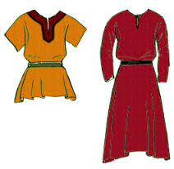
Some churches had instruments such as organs and bells. The organistrum or symphony (later known as a hurdy gurdy) was also found in churches. Two people were required to play this stringed instrument--one to turn the crank and the other to play the keys.
Towns
ollowing 1000, peace and order grew. As a result, peasants began to expand their farms and villages further into the countryside. The earliest merchants were peddlers who went from village to village selling their goods. As the demand for goods increased--particularly for the gems, silks, and other luxuries from Genoa and Venice, the ports of Italy that traded with the East--the peddlers became more familiar with complex issues of trade, commerce, accounting, and contracts. They became savvy businessmen and learned to deal with Italian moneylenders and bankers. The English, Belgians, Germans, and Dutch took their coal, timber, wood, iron, copper, and lead to the south and came back with luxury items such as wine and olive oil.
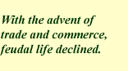
With the advent of trade and commerce, feudal life declined. As the tradesmen became wealthier, they resented having to give their profits to their lords. Arrangements were made for the townspeople to pay a fixed annual sum to the lord or king and gain independence for their town as a "borough" with the power to govern itself. The marketplace became the focus of many towns.
Education:
There was not established education during the Middle ages. Anything that the lower class or peasants learned was from the church whom greatly impacted their lives.
The Nobles of the upper class were often educated but they did so within their own homes, there were not schools that they attended. In addition, there were not any inventions that were coming out in Europe at this time.

Comparing Europe and the Ottoman Empire
Category | Ottoman Empire – write description | Medieval Europe- write description
Government System (monarchy? Government system?)

Religion (was there dominant religion political?)
Entertainment:

Advancements: (Inventions and Education)

Health:

Homes:

Critical Thinking:
- Which region do you think was more advanced? Explain your answer in 3 sentences….

- Europe and the Ottoman Empire began to trade with each other through the Cape of Good Hope, how do you think Europeans felt when they saw the Ottoman Empire? Explain you answer, one word is not enough.

- What do you think they would compare the Ottoman Empire to? (This of Europe’s past history)?

- If you though another civilization was far more advanced than you, what would you try to do?

